# Report on my experience in the Fistula Surgery Campaign in Kamuli District, Uganda

In the Beginning of ougost 2023 I was invited by my colleague Dr Ian Asimwe a senior urologist and fistula surgeon through a partnership **UCIF** to join a team of Surgeons on to save fistula patients in Kamuli District Uganda.

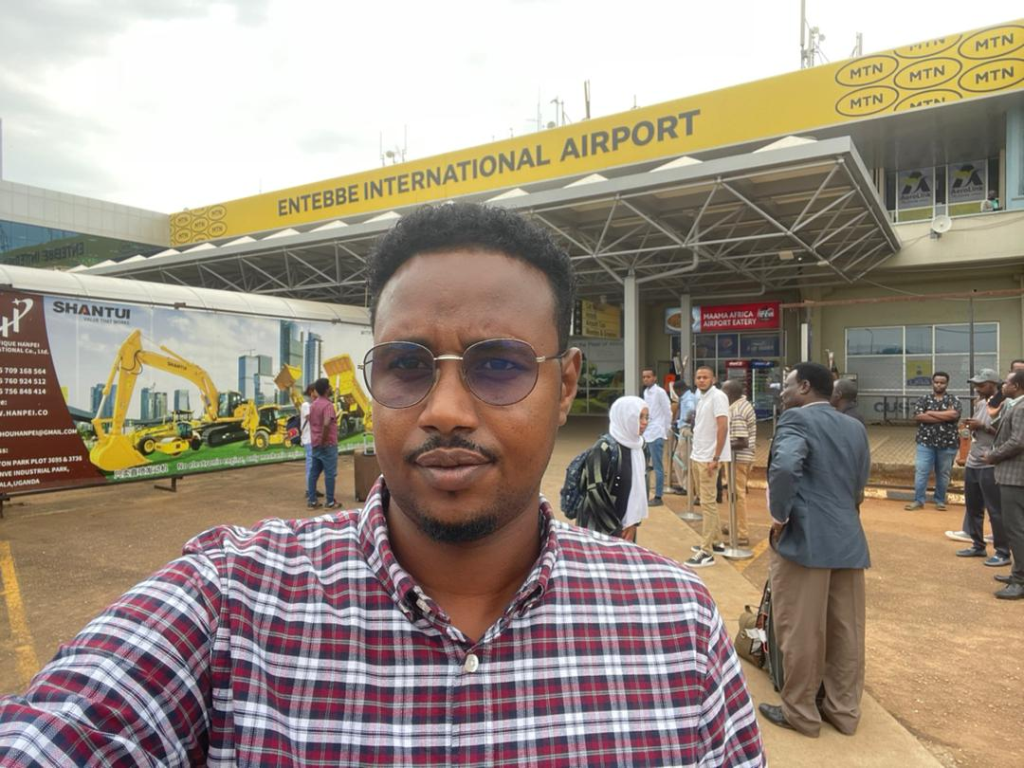

ENTEBBE I AIRPORT ARIVAL

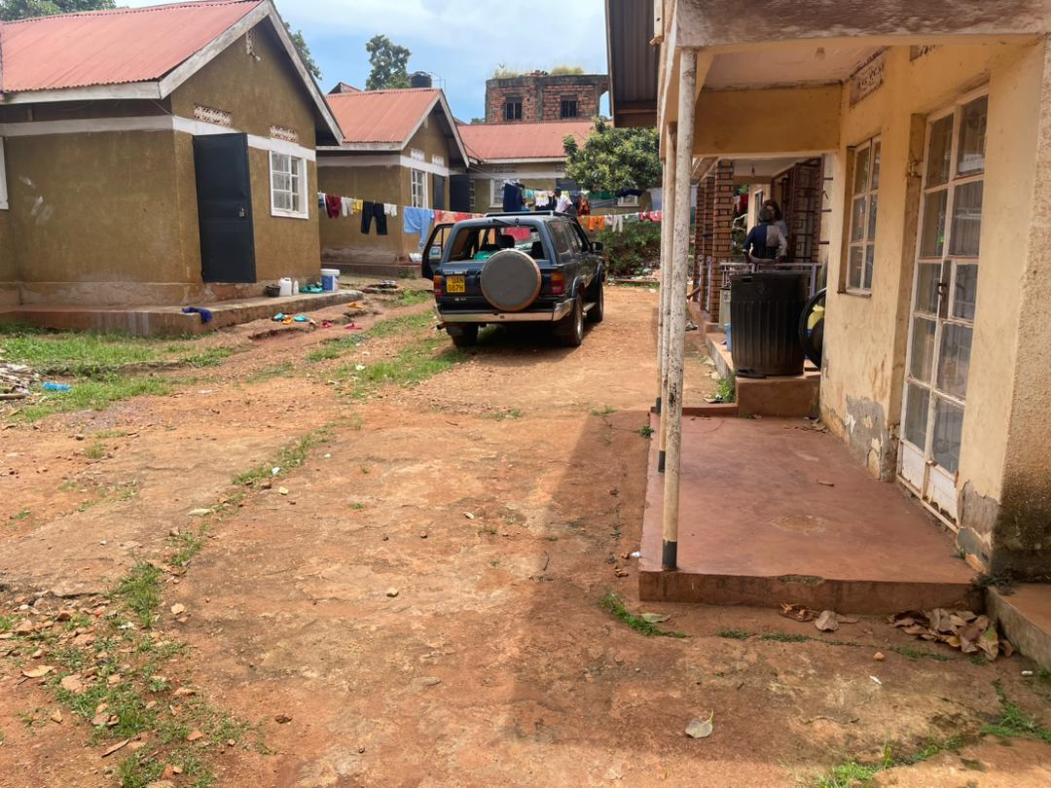

**Dr IAN ASIIME MOMS HOME**

Kamuli District is a district located in the Eastern Region of Uganda, in East Africa. It is one of the districts in the country and is situated approximately 140 kilometers northeast of the capital city, Kampala.

Fistula is a dehumanizing condition that happens to usually young girls delivering children as a result of disproportion between the baby’s head and the incompletely developed pelvis leading to often the death of the baby and a hole forming between the girl’s vagina and urinary bladder leading to continuous leakage of urine. It usually happens in less developed societies with malnutrition, early marriages and unavailability of obstetric services.

I had the privilege of participating in a fistula surgery campaign in Kamuli District, Uganda. This report aims to provide an overview of my experience during the campaign, focusing on the acquisition of new surgical skills and the collaborative efforts of the supportive team.

During the campaign, I had the opportunity to acquire new surgical skills. Working under the guidance of experienced surgeons like Mhairi collie, Ian Asimwe and Cathrine Reimers , I witnessed and actively participated in fistula repair surgeries. The hands-on experience allowed me to enhance my understanding of the surgical procedures involved in addressing obstetric fistula.

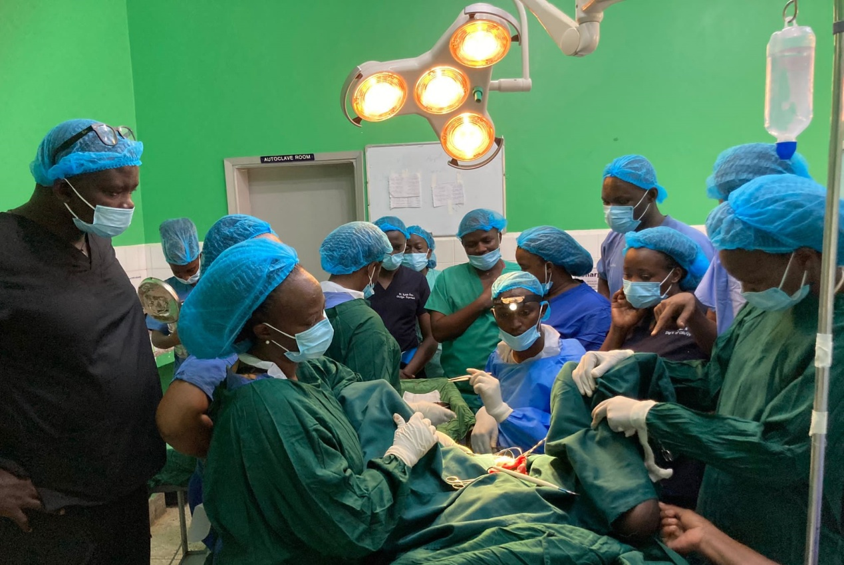

**Dr Ian Asiimwe explaining while operating**

It was an invaluable learning experience that will undoubtedly contribute to my professional growth as a healthcare provider and fistula surgeon.

The most cases that I earned more were urinary diversions, ectopic ureters, intra-abdominal RVF repairs and many others.

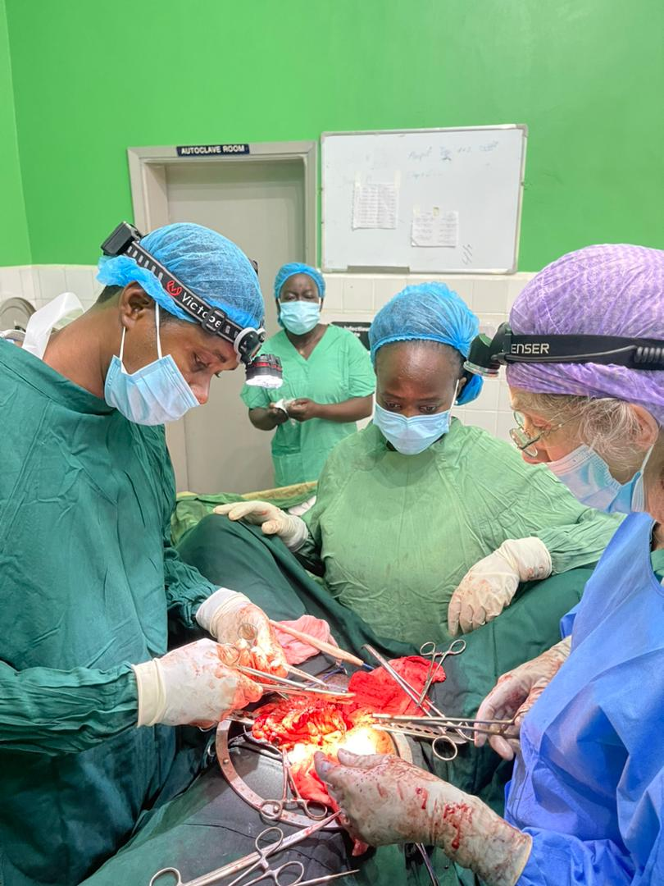

**Mainz Pouch II urinary diversion with Dr Mhairi collie**

Throughout the campaign, the organizing team ensured that nutritious meals were provided to all participants. This was crucial in maintaining our energy levels and overall well-being during the demanding surgical procedures. The provision of good meals not only enhanced our physical stamina but also fostered a sense of camaraderie and support among the team members.

The campaign team consisted of a diverse group of professionals dedicated to addressing the complex challenges of obstetric fistula. It included doctors, nurses, midwives, photographers, and other support staff. The collective expertise and collaborative spirit of the team were instrumental in the success of the campaign. The doctors provided guidance and supervision, the nurses and midwives ensured proper patient care, and the photographers captured the stories and experiences, raising awareness about the campaign's impact. among the team Mrs Ishbel Cambpel was amazing and help full we where travel together go and back to kamuli .

The fistula surgery campaign in Kamuli District, Uganda, had a profound impact on the lives of the women affected by obstetric fistula. By providing surgical interventions, the campaign aimed to restore continence and alleviate the physical and emotional suffering of these women. The acquired surgical skills, along with the supportive team environment, contributed to a meaningful and fulfilling experience.

However, it is important to recognize that fistula surgery campaigns face challenges such as limited resources and the need for long-term sustainable solutions. Continued support, funding, and community engagement are essential to ensure the lasting impact of such campaigns and the empowerment of women affected by obstetric fistula in Uganda.

In conclusion, my participation in the fistula surgery campaign in Kamuli District, Uganda, was a transformative experience. The acquisition of new surgical skills, the provision of nourishing meals, and the collaboration with a helpful and diverse team all contributed to the success of the campaign. I am grateful for the opportunity to make a positive impact on the lives of women affected by obstetric fistula and to be part of a larger movement towards better maternal healthcare.

# Dr Abdirisak Hassan Artan

## *Obstetrician and gynecologist/fistula surgeon Figo Fellow*

## *Keysaney and Sahal wowen’S and fistula hospital.*

## *National fistula program coordinator MOH Somalia*

## *Mogadishu-Somalia*

|  |  |
| --- | --- |
| C:\Users\pc\Downloads\k trip.jpg | C:\Users\pc\Downloads\with Dr collie.jpg |
| C:\Users\pc\Downloads\ktrip.jpg | C:\Users\pc\Downloads\d0ebfd2e-0c47-4148-b1d7-4509cc8c012e.jpg |

